SQL Data Analysis on Covid19 Dataset

1 Total Confirmed Cases and Deaths by Country



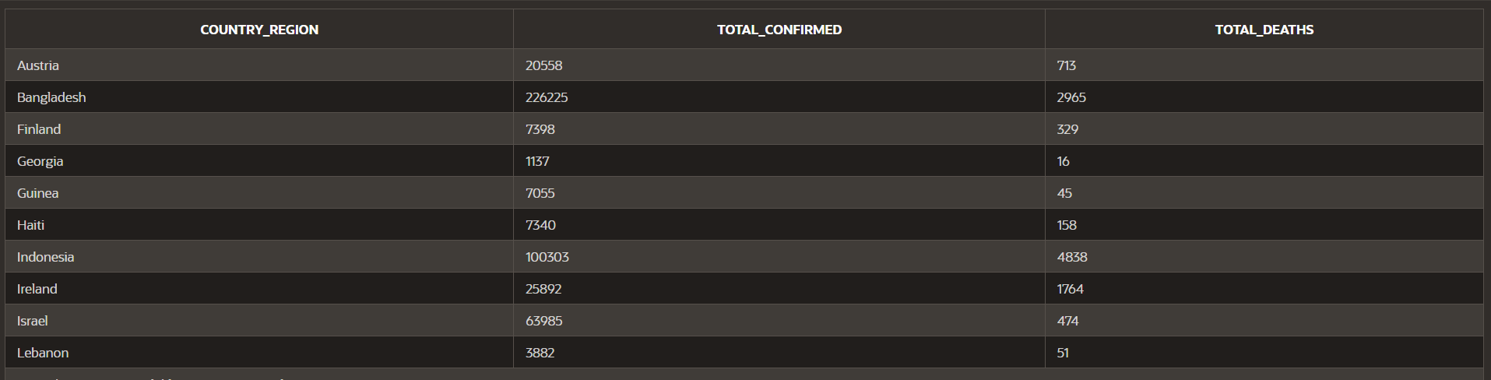OUTPUT:

2 Top 10 Countries with the Highest New Cases

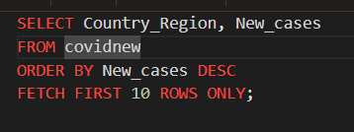

OUTPUT:

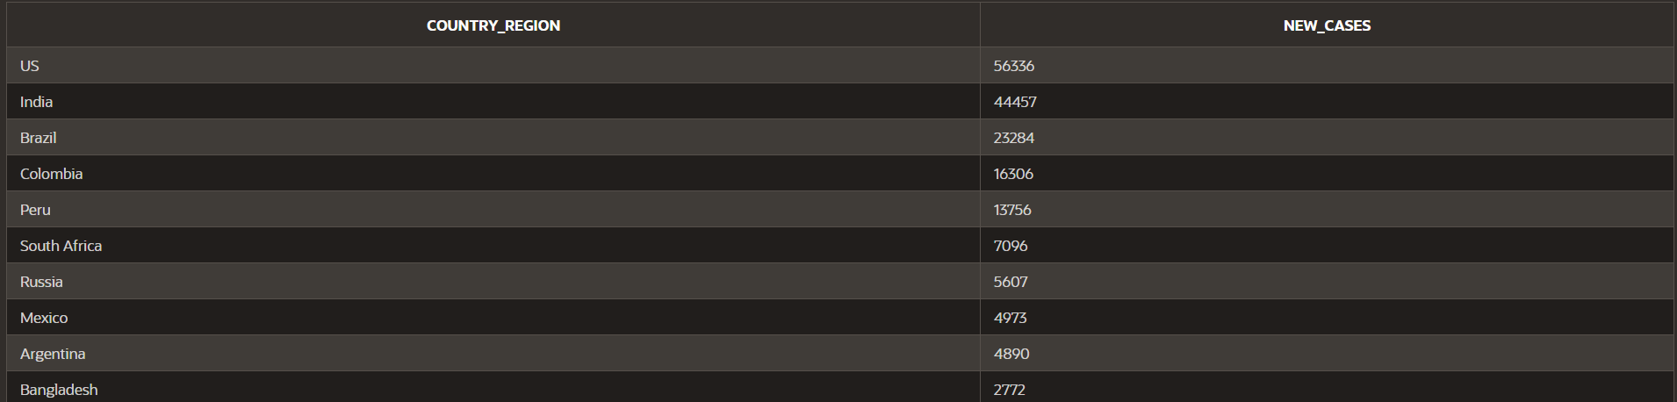

3 Countries with More than 100,000 Active Cases

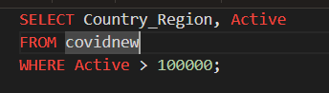

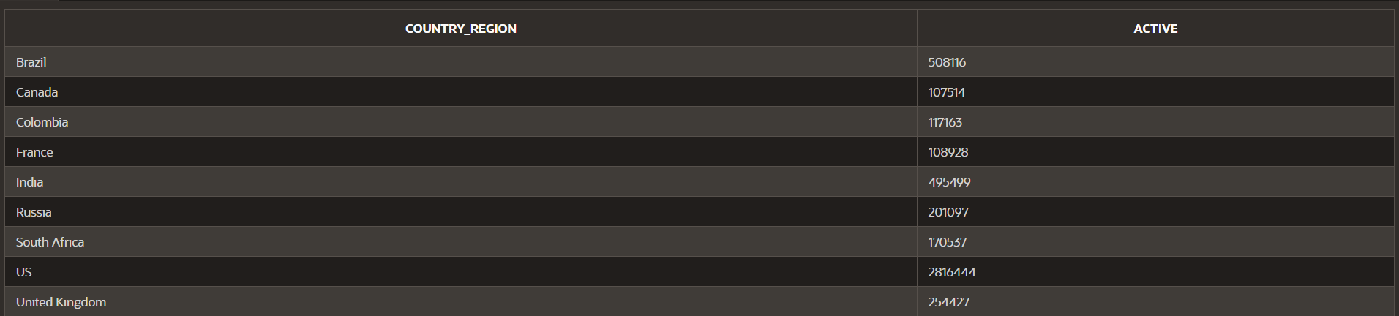OUTPUT:

4 Total Recoveries by WHO Region

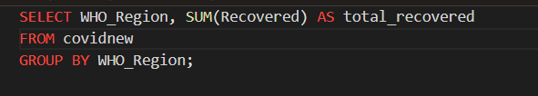

OUTPUT:

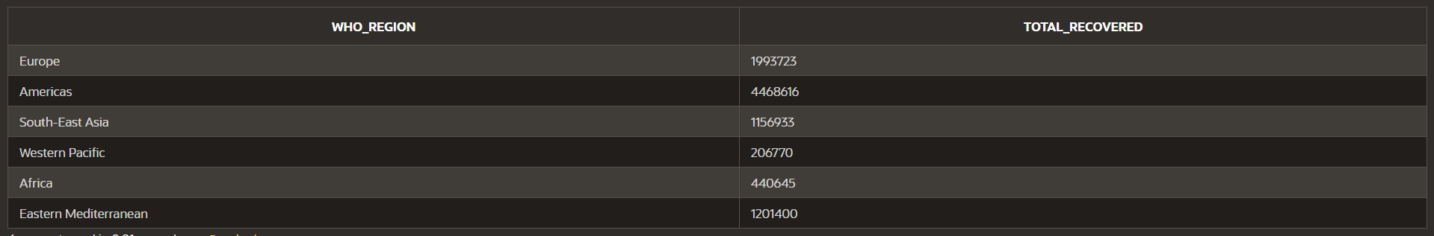

5 Countries with a Recovery Rate Higher Than 80%

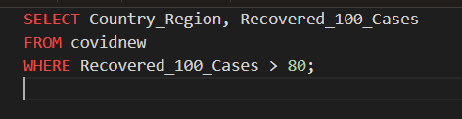

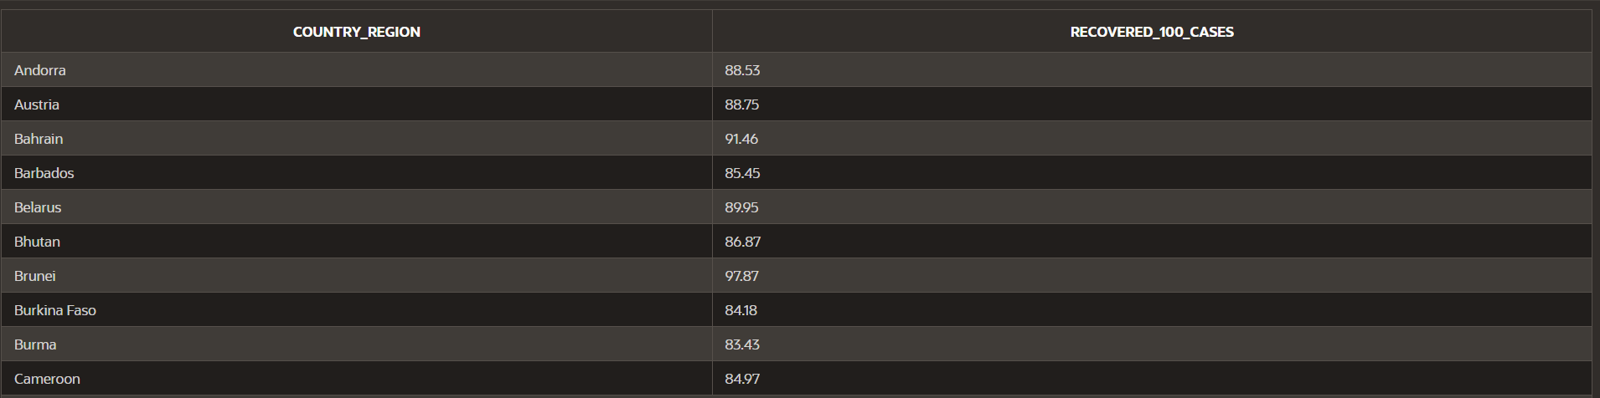OUTPUT:

6 Average Death Rate Across All Countries

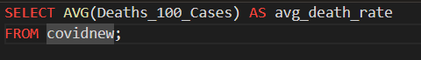

OUTPUT:

7 Countries with the Highest Weekly Percentage Increase in Cases

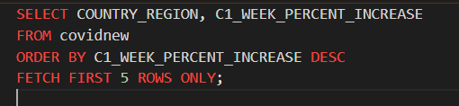

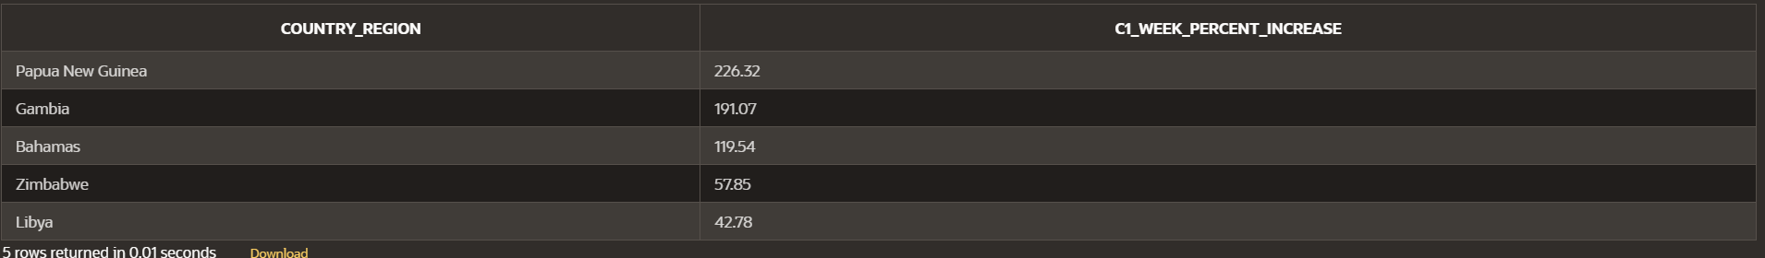OUTPUT:

8 Countries with the Largest Weekly Change in Confirmed Cases

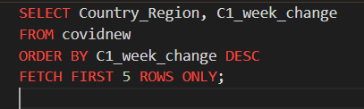

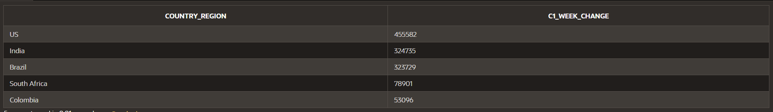OUTPUT:

9 Calculate the Case Fatality Rate (CFR) for Each Country

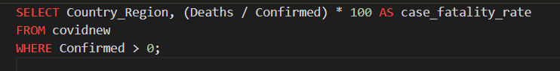

OUTPUT:

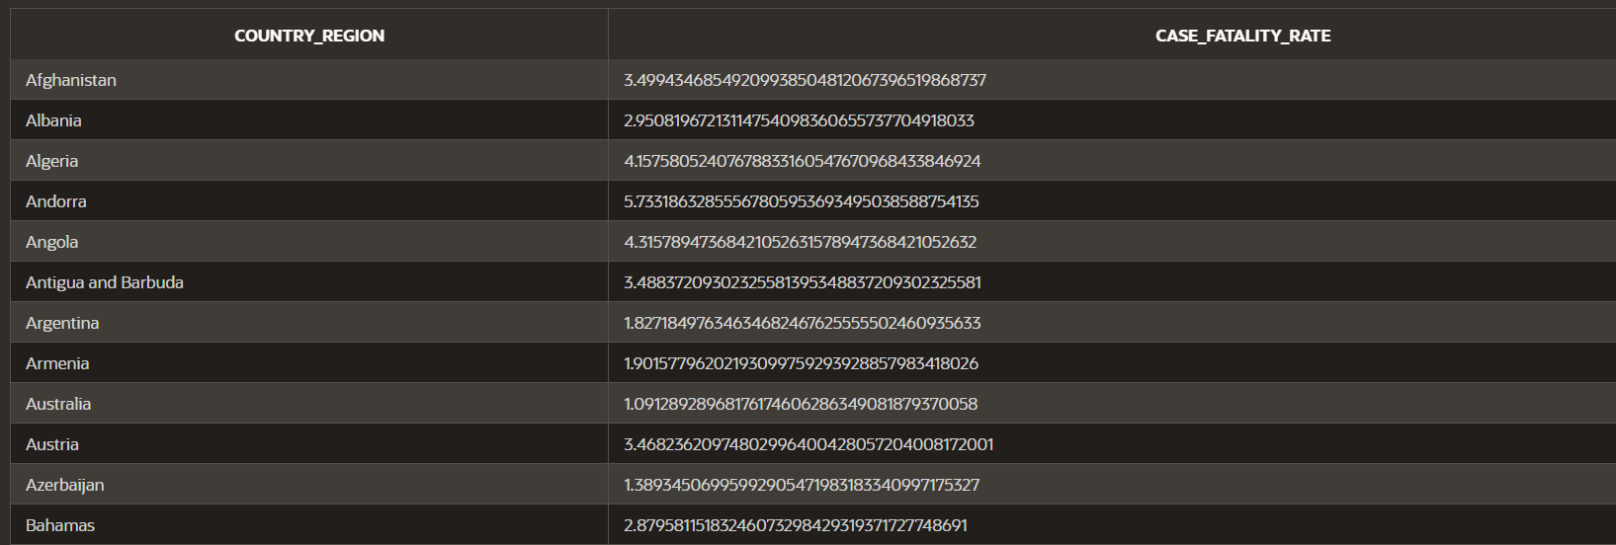

10 Total Cases and Deaths per WHO Region, Ranked by Total Deaths

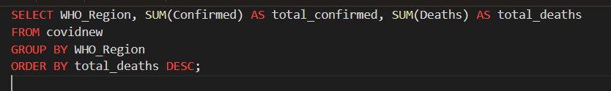

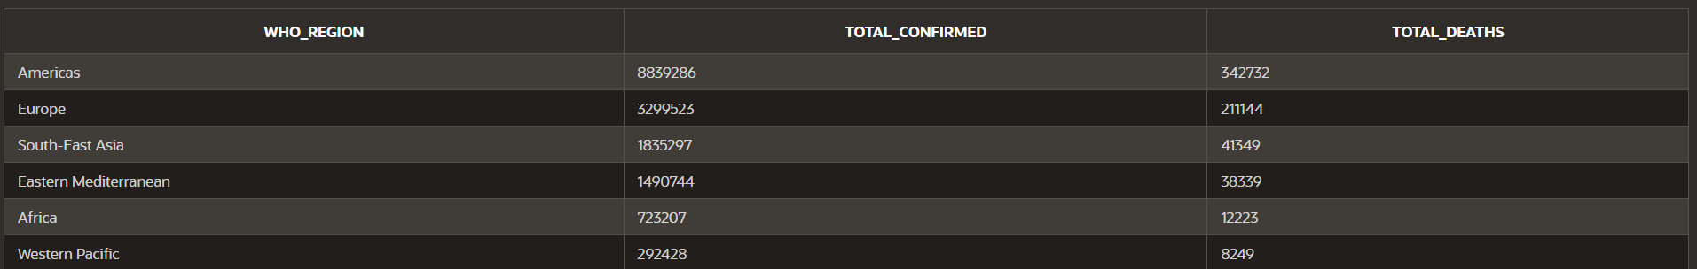OUTPUT:

11 Countries Where the Death Rate Exceeds the Recovery Rate



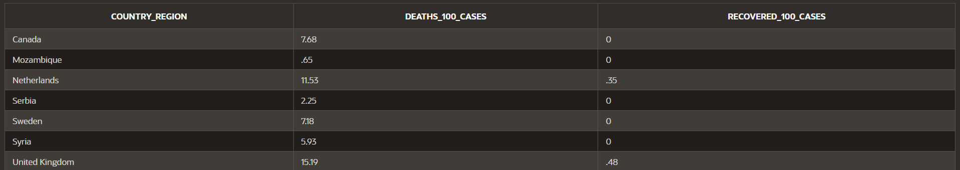OUTPUT:

12 Rank Countries by Total Confirmed Cases and Show the Top 5

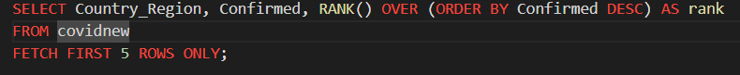

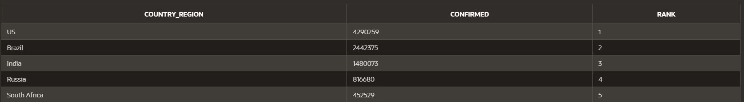OUTPUT:

13 WHO Regions with a Recovery Rate Below 75%

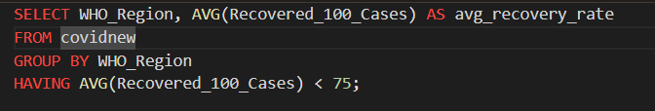

OUTPUT:

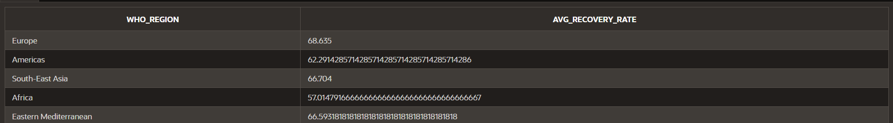

14 Countries with the Highest Confirmed-to-Death Ratio

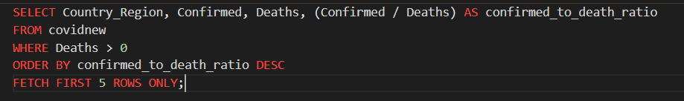

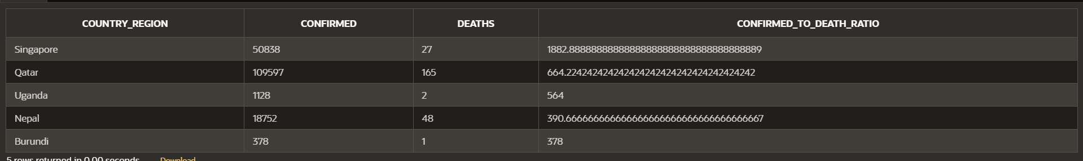OUTPUT:

15 7-Day Rolling Average of New Cases for Each Country

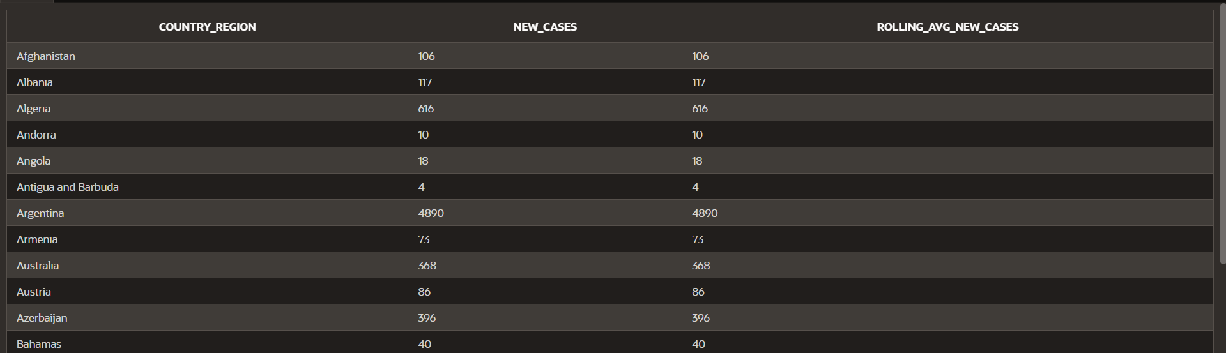OUTPUT:

16 Countries with the Largest Decrease in Active Cases Over the Last Week

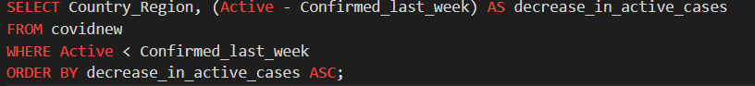

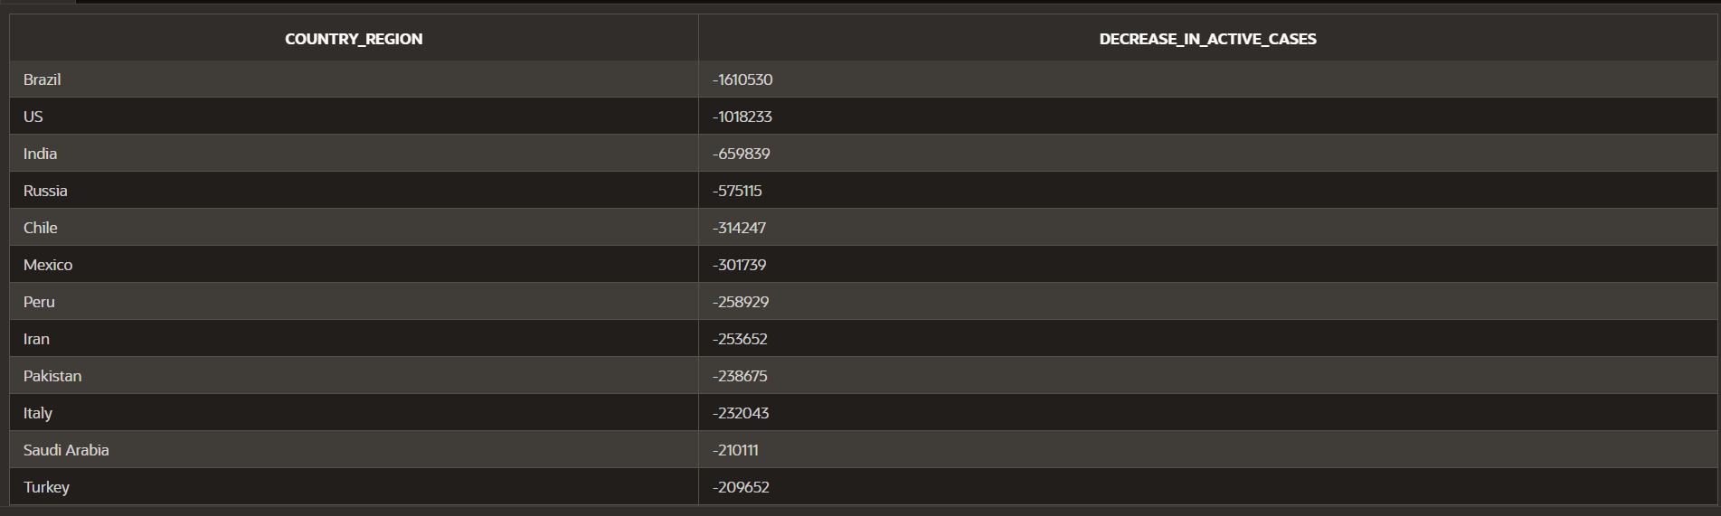OUTPUT:

17 Countries with the Highest Death Proportion Compared to New Cases

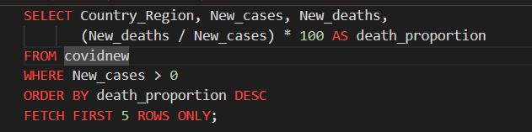

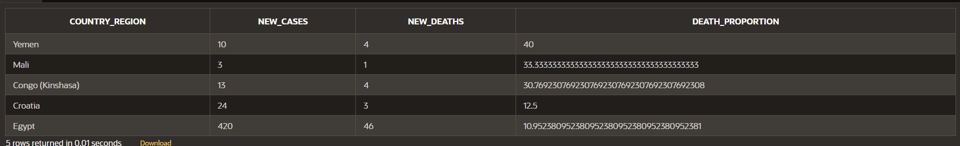OUTPUT:

18 Top 5 WHO Regions by Case Fatality Rate (Deaths / Confirmed)

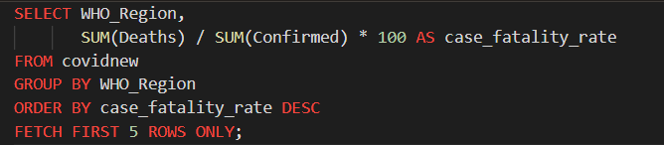

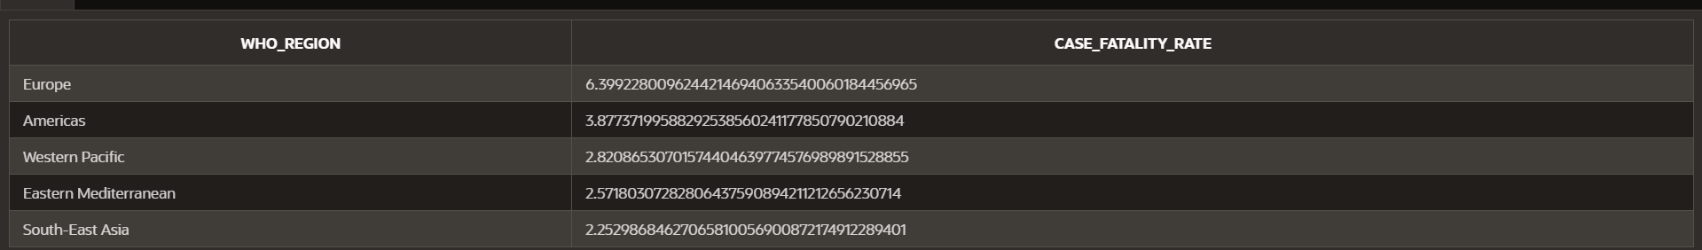OUTPUT: